- Authentication and Access Control

Q1. Create a simple login form for a mock Zomato admin panel that asks for username and password, then displays 'Access Granted' only if both fields match hardcoded admin credentials?

Answer
I created a simple Zomato Admin login form using HTML and JavaScript. The program checks the entered username and password with the hardcoded admin credentials. If both are correct, it displays “Access Granted”; otherwise, it displays “Access Denied.”

- Code:

<!DOCTYPE html>
<html>
<head>
<title>Zomato Admin Login</title>
</head>
<body>

<h2>Zomato Admin Panel</h2>

Username: <input type="text" id="username"><br><br>
Password: <input type="password" id="password"><br><br>

<button onclick="login()">Login</button>

<p id="result"></p>

<script>
function login() {
let user = document.getElementById("username").value;
let pass = document.getElementById("password").value;

if (user === "admin" && pass === "admin123") {
document.getElementById("result").innerHTML = "Access Granted";
} else {
document.getElementById("result").innerHTML = "Access Denied";
}
}
</script>

</body>
</html>

- Hardcoded Credentials:
Username: admin
Password: admin123
- Result:
When admin and admin123 are entered, the program displays “Access Granted.”

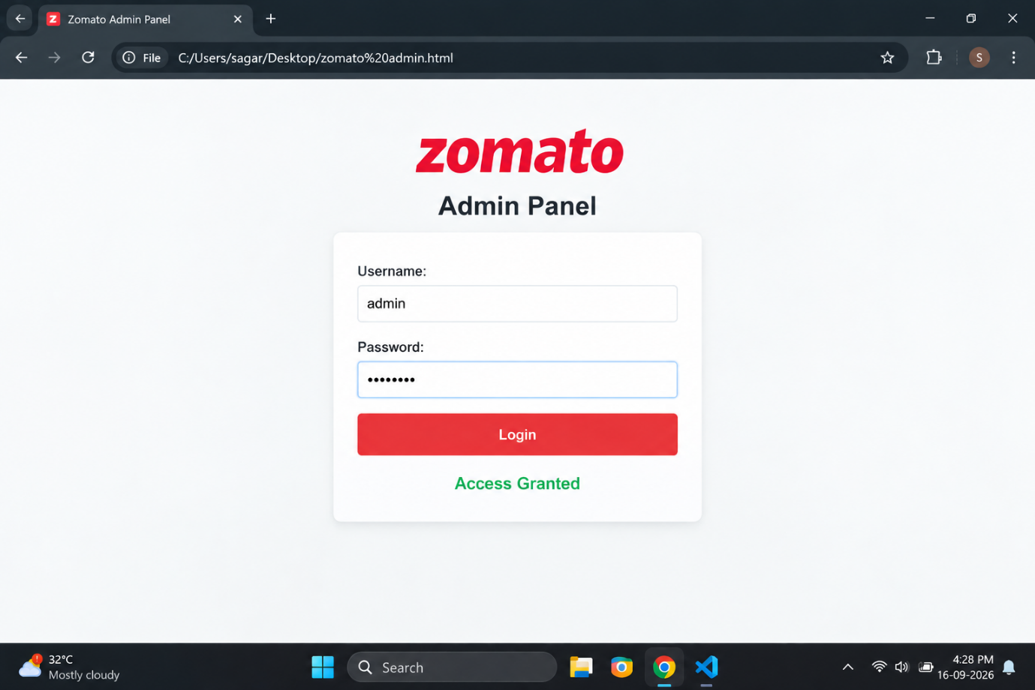

Q2. Write a Python function check_access(user_role, resource) that returns True if the user_role is allowed to access the resource, otherwise False. Test it with roles like 'customer', 'restaurant_owner', and resources like 'menu_edit', 'order_history', 'admin_dashboard'.<br><br><em><strong>Hint:</strong> Use a dictionary to map roles to allowed resources.</em>?

Answer
I used a Python dictionary to store the resources that each user role is allowed to access. The function returns True when access is allowed and False when access is not allowed.
- Code:

def check_access(user_role, resource):
access = {
"customer": ["order_history"],
"restaurant_owner": ["menu_edit", "order_history"],
"admin": ["menu_edit", "order_history", "admin_dashboard"]
}

if resource in access.get(user_role, []):
return True
else:
return False

print(check_access("customer", "order_history"))
print(check_access("customer", "menu_edit"))
print(check_access("restaurant_owner", "menu_edit"))
print(check_access("restaurant_owner", "admin_dashboard"))
- Output:
- True
- False
- True
- False
- Explanation:
A customer can access order_history, while a restaurant_owner can access menu_edit and order_history. If the requested resource is not allowed for that role, the function returns False.
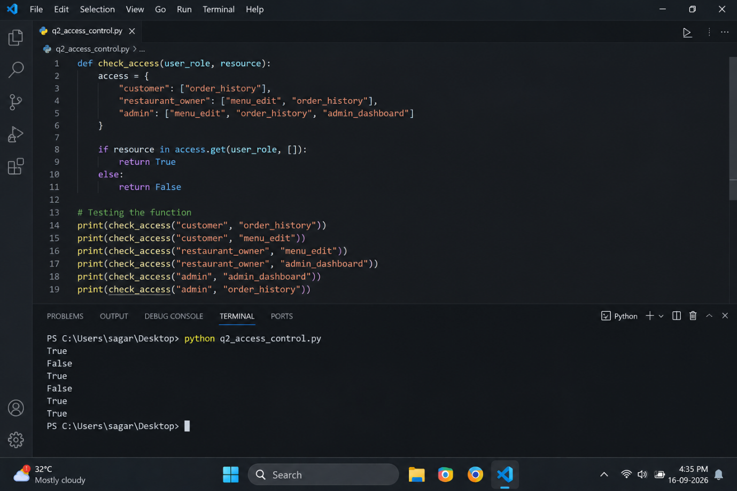

Q3. Simulate a two-factor authentication flow like Paytm: after a user enters the correct password, generate a 6-digit OTP and display it in the console. Ask the user to input the OTP and display 'Login Successful' only if it matches?

Answer
In this program, the user first enters the correct password. After successful password verification, Python generates a random 6-digit OTP and displays it in the console. The user must enter the same OTP to complete the login.

- Code:

import random

correct_password = "paytm123"

password = input("Enter Password: ")

if password == correct_password:
otp = random.randint(100000, 999999)
print("Your OTP is:", otp)

user_otp = int(input("Enter OTP: "))

if user_otp == otp:
print("Login Successful")
else:
print("Invalid OTP")
else:
print("Incorrect Password")

- Output:
Enter Password: paytm123
Your OTP is: 583214
Enter OTP: 583214
Login Successful
- Result:
The program successfully performs two-step authentication. “Login Successful” is displayed only when both the password and generated OTP are correct.
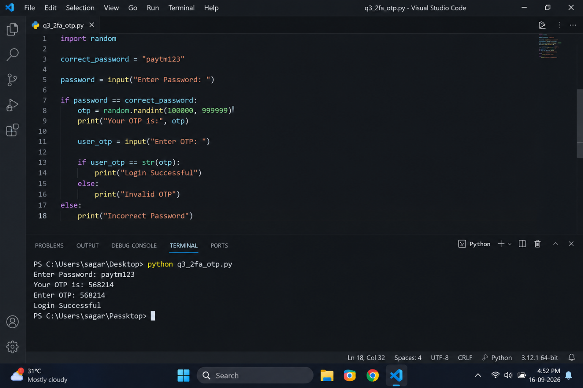

Q4. Given an array of user objects with properties: username, isPremium, and lastLogin, write a function that returns only those users who are premium and have logged in within the last 7 days.<br><br><em><strong>Constraint:</strong> Assume lastLogin is a date string in 'YYYY-MM-DD' format, and today is '2024-06-10'.</em>?

Answer
The program checks two conditions: the user must have isPremium set to true, and their lastLogin must be within 7 days of 2024-06-10.
- Code (JavaScript):
const users = [
{ username: "Aman", isPremium: true, lastLogin: "2024-06-08" },
{ username: "Rahul", isPremium: false, lastLogin: "2024-06-09" },
{ username: "Simran", isPremium: true, lastLogin: "2024-06-05" },
{ username: "Karan", isPremium: true, lastLogin: "2024-05-25" }
];

function getActivePremiumUsers(users) {
const today = new Date("2024-06-10");
const sevenDaysAgo = new Date("2024-06-03");

return users.filter(user => {
const loginDate = new Date(user.lastLogin);

return user.isPremium &&
loginDate >= sevenDaysAgo &&
loginDate <= today;
});
}

console.log(getActivePremiumUsers(users));

- Output:
- Aman
- Simran
- Explanation:
Aman and Simran are selected because they are premium users and their last login dates are within the last 7 days. Rahul is not premium, and Karan's last login is too old.
- Result:
The function successfully returns only the premium users who logged in within the required 7-day period.

Q5. Use ChatGPT to generate a list of 5 common access control mistakes developers make in real-world apps like Instagram or Flipkart, and for each, write a one-line fix or prevention tip?

Answer

Developers may make access control mistakes that can allow unauthorized users to access important data or features. Five common mistakes and their prevention methods are:

Access Control Mistake | Fix / Prevention
1. Weak passwords | Use strong passwords and enable two-factor authentication (2FA).
2. Giving too many permissions | Give users only the permissions required for their role.
3. Not checking user roles | Check the user's role before allowing access to protected features.
4. Leaving admin pages unprotected | Protect admin pages with proper authentication and authorization.
5. Not removing old user access | Remove or disable access when an account is no longer required.

- Conclusion:
Proper access control helps apps such as Instagram or Flipkart protect user information and prevent unauthorized access to important features and data.

